* + 1. Application Security and Pre-approval Key

When the user logs in to the document vault, and new M-Files Application is ready to be downloaded, the application security dialog pops up and prompts the user whether the application should be used. See the Security section for more information.

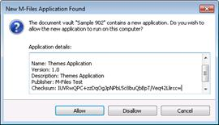

**The application security dialog.**

Administrator may wish to pre-approve certain applications, in order to avoid user confusion. This can be done by distributing a registry key that specifies the vault GUID, the application GUID, and the application checksum. The vault GUID can be copied from the M-Files Server Administrator application (in vault properties dialog), the application GUID appears in the application definition file, and the checksum can be seen on the last line of the application security dialog. When adding the GUIDs to registry, please ensure that they are placed inside curly brackets.

The pre-approval registry key is defined as follows:

|  |  |
| --- | --- |
| Key | HKEY_LOCAL_MACHINE\SOFTWARE\Motive\M-Files\<version>\Client\MFClient\ApplicationAccess\<vault GUID> |
| Value name | <Application GUID> |
| Value data | <Application checksum> |

The picture below shows an example how the configuration would show in Registry Editor:

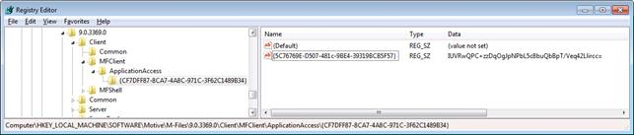

**Pre-shared application approval key as seen in Registry Editor.**

In large installations administrators may wish to distribute the registry settings via Active Directory Group Policies or similar registry setting delivery mechanisms.